**MOISTURE IN OIL SENSOR**

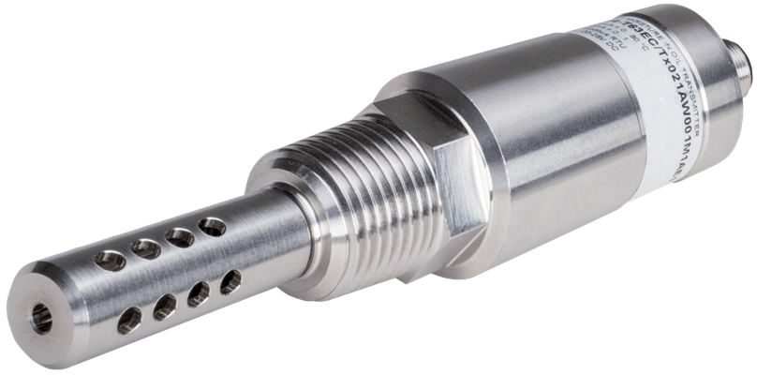The compact moisture in oil sensor is designed for reliable online monitoring of the moisture in transformer, engine, lubrication or hydraulic oil as well as in diesel fuel. Besides the accurate measurement of water activity (aw) and temperature (T), the EE364 calculates the absolute water content (x) of the oil in ppm.

#### Outstanding Measurement Performance

The sensor employs high end E+E humidity sensing elements which feature outstanding long term stability and high resistance to pollution.

#### Functional Design

The small size and robust stainless steel enclosure, together with the choice of process connections allow easy and space-saving installation.

#### Analogue and Digital Outputs

The aw, T and x measured data is available on two freely configurable 4 - 20 mA analogue outputs and on the RS485 interface with Modbus RTU protocol. The wide scaling range of the analogue output facilitates the EE364 implementation in existing monitoring and control systems.

#### Configurable and Adjustable

The setup and adjustment of the EE364 can be easily performed with an optional configuration adapter and the free [EE-PCS Product Configuration Software.](https://www.epluse.com/configurator)

# Features

**Measurement performance**

» Water activity (aw), water content (x), temperature (T)

» Oil temperature -40...100 °C (-40...212 °F)

» Suitable for transformer, lubrication and hydraulic oil, as well as for diesel fuel

**Configurable and adjustable**

» Service interface

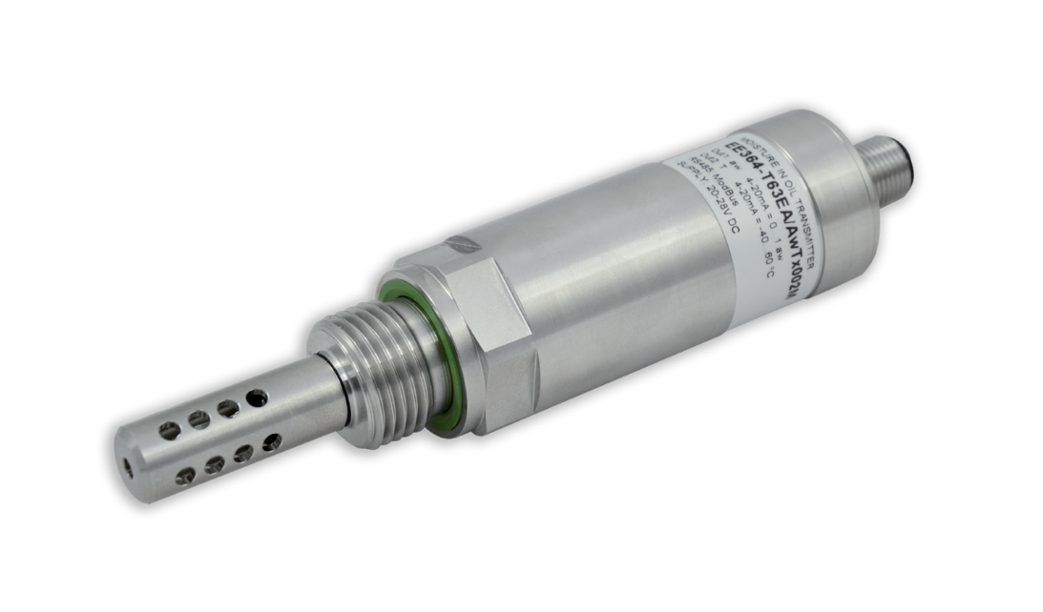

» Free configuration software

**Outputs**

» 2 x 4 - 20 mA output, wide scaling range

» Modbus RTU

» Industrial M12x1 connector

**Inspection certificate**

**according DIN EN 10204-3.1**

**Mechanical construction**

» Stainless steel enclosure and filter cap

» Pressure tight up to 20 bar

» Process connection with ISO or NPT thread

» IP65 / NEMA

# Measurement of water activity aw / water content

The moisture in oil can be expressed in absolute or relative terms.

**Water activity aw** is a relative measure for moisture in oil. It represents the ratio between the actual amount of dissolved water and the maximum possible amount of dissolved water in the oil at a given temperature. The aw value indicates how close to saturation is the oil. aw = 0 means dry oil (no water at all), aw = 1 means fully saturated oil. Water activity does not depend on the type of oil.

**Water content x** is an absolute measure for the amount of water in the oil (dissolved, emulsified or separated). The water content is usually expressed in ppm or mg water / kg oil and it is independent from the oil temperature. For assessing the degree of saturation, x must be regarded together with T.

EE364 calculates x based on the measured aw and T values. The calculation is oil dependent and requires a set of oil specific parameters. E+E offers the service of determining the oil specific parametrs, see section “Accessories” below. The parameters can be set upon order or uploaded to EE364 using the [EE-PCS Product Configuration Software.](https://www.epluse.com/configurator)

# Technical data

### Water activity (aw) / water content (x)

Working range 0...1 / 0...100 000 ppm

(ppm output is valid in the range 0...100 °C (32...212 °F))

Accuracy**1)** at 20°C (68 °F) ±0.02 (aw = 0...0.9) ±0.03 (aw = 0.9...1)

Response time t90 at 20°C (68 °F), in still oil, typ. 10 min.

### Temperature

Maximum working range -40...100 °C (-40...212 °F)

Accuracy**1)** at 20°C in oil ±0.2 °C (0.36 °F)

Resolution 0.01 °C (0.18 °F)

## Output

**Analogue output (scalable)** 2 x 4 - 20 mA (3-wire) RL < 500 Ohm Resolution 2 µA

**Digital interface** RS485 (EE364 = 1 unit load)

Protocol Modbus RTU

Default settings Baud rate 9600**2)**, parity even, 1 stop bit, Modbus address 234

## General



Power supply class III**3)** 10*) - 28V DC *) 10V+0.02*RL

Power consumption <20 mA + load current

Electrical connection M12x1 plug 8 poles

Pressure rating 0...20 bar (0...290 psi)

Enclosure material Stainless steel 1.4404 (AISI 316L)

Protection rating IP65 / NEMA 4

Filter Stainless steel

Oil temperature -40...80 °C (-40...176 °F) / -40...100 °C (-40...212 °F)

Ambient temperature -40...60 °C (-40...140 °F) / -40...80 °C (-40...176 °F)

Storage temperature -40...60 °C (-40...140 °F)

Electromagnetic compatibility EN 61326-1 EN 61326-2-3 Industrial environment



FCC Part15 Class A ICES-003 Class A

1. The accuracy statement includes the uncertainty of the factory calibration with an enhancement factor k=2 (2 x standard deviation).

The accuracy was calculated in accordance with EA-4/02 and with regard to GUM (Guide to the Expression of Uncertainty in Measurement).

1. Supported baud rates: 9 600, 19 200 and 38 400; find more details about communication setting in the User Manual and the Modbus Application Note at [www.epluse.com/EE364.](https://www.epluse.com/ee364)
2. USA & Canada class 2 supply required.

# Dimensions

Values in mm (inch)

140 (5.5)

92 (3.6)

34 (1.36)

G1/2“

AD27

77 (3)

### ISO thread

Ø12 (0.5)

Ø30 (1.2)

**NPT thread**

51 (2) 89 (3.5)

1/2“NPT

AD22

74 (2.9)

# Ordering Guide

|  |  |  |  |
| --- | --- | --- | --- |
|  | | | **EE364-** |
| **Hardware** | **Process connection** | G 1/2" ISO thread  1/2" NPT thread | **PA1**  **PA2** |
| **Fluid temperature** -40...80 °C (-40...176 °F)  -40...100 °C (-40...212 °F) | | **HM1**  **HM2** |
| **Filter** | Stainless steel, for flow < 1 m/s (< 3.28 ft/s)  Stainless steel, for flow > 1 m/s (> 3.28 ft/s) | **F13 F18** |
| **Accessories** No accessories  M12x1 cable socket, for self assembly | | **AC0**  **AC2** |
| **Software Setup - Analogue Outputs** | **Output 1** | Water activity aw [ ] Water content x [ppm] Temperature T [°C]  Temperature T [°F] | **no code MA70 MA1**  **MA2** |
| **Scaling 1 low** 0  Value | | **no code**  **SAL*Value*** |
| **Scaling 1 high** 1  Value | | **no code**  **SAH*Value*** |
| **Output 2** | Temperature T [°C] Temperature T [°F] Water activity aw [ ]  Water content x [ppm] | **no code MB2 MB67**  **MB70** |
| **Scaling 2 low** -20  Value | | **no code**  **SBL*Value*** |
| **Scaling 2 high** 80  Value | | **no code**  **SBH*Value*** |
| **Units (Modbus RTU)** | Metric (SI)  Non-metric | **U1**  **U2** |
| **Oil parameterization for** Mineral transformer oil  **water content calculation** Customer specific oil | | **no code**  **PPMxxx** |

Order Example

#### EE364-PA1HM1F13AC2U1

Process connection: 1/2" ISO thread

Fluid temperature: -40...80 °C (-40...176 °F)

Filter: Stainless steel, for flow < 1m/s

Accessory: M12x1 socket connector, for self assembly Units: Metric (SI)

# Accessories

(For further Information, see da[tasheet "Accessories"](https://www.epluse.com/fileadmin/data/product/accessories/datasheet_accessories.pdf))

|  |  |
| --- | --- |
| Determination of oil specific parameters | ppm-cal |
| Modbus configuration adapter | HA011013 |
| EE-PCS Product Configuration Software | EE-PCS |
| (free download: [www.epluse.com/configurator)](https://www.epluse.com/configurator) |  |
| M12x1 8 pole cable socket for self assembly | HA010704 |
| M12x1 8 pole shielded connection cable, socket/flying leads |  |
| 1.5 m (4.9 ft) | HA010322 |
| 5 m (9.8 ft) | HA010324 |
| 10 m (16.4 ft) | HA010325 |
| Sampling cell with shut-off function, PN40, DN25 | HA050109 |